

**TEAM – 27**

**DOCUMENTATION**

 



AWS



24 Hours Hackathon on AWS Organised by SRI VASAVI ENGINEERING COLLEGE With Collabration of BRAINOVISIOn

TEAM MEMBERS DETAILS :

| **ROLL NUMBER** | **MEMBER NAME** | **MEMBER E-MAIL** | **BRANCH** |
| --- | --- | --- | --- |
| 22A81A05E0 | Challa. Vishnu Vardhan | challavishnu96@gmail.com | CSE |
| 22A81A05H5 | Pallapolu.Sai Meghana | saimeghana1119@gmail.com | CSE |
| 22A81A05E6 | Ganni.Mahitha Lakshmi | 22a81a05e6@sves.org.in | CSE |
| 22A81A05G8 | Mohammad.Azmatulla | md.azmatulla.22@gmail.com | CSE |
| 22A81A05G9 | Mohammad.Rahimunnisa | rahimunnisa2414@gmail.com | CSE |
| 22A81A05G6 | Mareedu.Sai Ram | 22a81a05g6@sves.org.in | CSE |

INTRODUCTION

Amazon Web Services (AWS) is a comprehensive and widely used cloud computing platform offered by Amazon.com. Launched in 2006, AWS has since become a leading provider of cloud services, offering a vast array of computing resources, storage solutions, and networking capabilities to individuals, businesses, and organizations around the world.

**Some of the Key components and services within the AWS:**

**Compute Services: AWS offers a range of compute services, including Amazon EC2 (Elastic Compute Cloud) for scalable virtual servers, AWS Lambda for serverless computing, and AWS Elastic Beanstalk for easy application deployment.**

**Storage Services: AWS provides various storage solutions like Amazon S3 (Simple Storage Service) for scalable object storage, Amazon EBS (Elastic Block Store) for block storage, and Amazon Glacier for long-term data archival.**

**Database Services: AWS offers managed database services like Amazon RDS (Relational Database Service), Amazon DynamoDB for NoSQL databases, and Amazon Redshift for data warehousing.**

**Networking: AWS includes services for virtual private clouds (VPCs), content delivery (Amazon CloudFront), and load balancing (Amazon ELB) to ensure secure and high-performance networking.**

**Serverless Computing: AWS Lambda allows developers to run code without provisioning or managing servers, making it easier to build scalable and cost-effective applications.**

APPLICATIONS OF AWS

**Financial Services: Financial institutions use AWS for data analysis, risk management, and compliance with regulations, thanks to the robust security and compliance features.**

**Education: Educational institutions can leverage AWS for online learning platforms, data analytics, and research projects.**

**Government: AWS GovCloud is designed for government agencies, providing security and compliance features to meet government standards and regulations.**

**ADVANTAGES OF AWS:**

**Scalability:** **AWS allows you to scale your infrastructure up or down based on your needs, which is especially useful for businesses with fluctuating workloads. This elasticity helps you avoid over-provisioning or under-provisioning resources.**

**Cost-Efficiency: AWS offers a pay-as-you-go pricing model, which means you only pay for the resources you use. This can lead to cost savings compared to traditional on-premises infrastructure.**

**Flexibility and Variety of Services: AWS offers a wide range of services, including computing, storage, databases, analytics, machine learning, and more. This breadth of services allows you to build and deploy almost any type of application.**

**DIS ADVANTAGES OF AWS:**

**Cost Management: While AWS can be cost-effective, it's easy to overspend if you're not careful. Monitoring and optimizing your usage requires ongoing attention.**

**Complexity:** **The vast array of services and features in AWS can be overwhelming for beginners. Managing complex configurations and optimizing costs can be challenging.**

**Data Transfer Costs:** **Transferring data in and out of AWS can incur additional costs, which can be significant for high-volume applications**.

**Security Concerns:** **Although AWS provides robust security features and compliance certifications, the responsibility for securing your applications and data in the cloud ultimately falls on you**.

**Price variations:** **AWS offers various support plans, but premium support can be expensive. Depending on your level of expertise and requirements, you may find that support costs are a significant part of your AWS expenses.**



NETWORK CREATION:

* STEP 1: CREATING VPC

1)We have to give name

2)We have to give IP Address-(IPV4 CIDR)

3)Click on create VPC

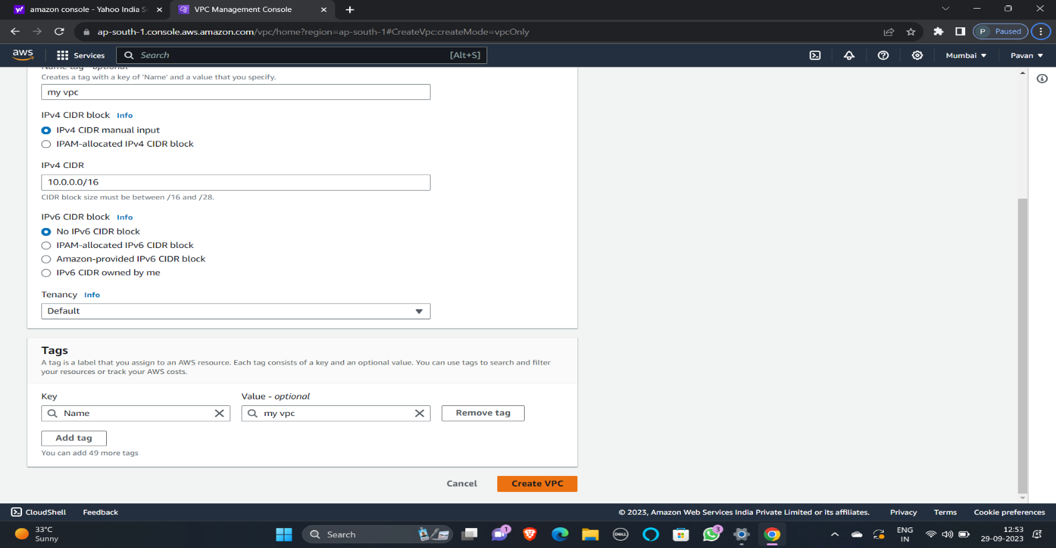

STEP 2: CREATING SUBNETS

1)NAME (Have to Select my VPC)

2)We have to fill subnet 1 details

1)Name (EX:10.0.1.0/24-1A-PUB)

2)Availability Zone (Asia paciffic-1a)

3)IPV4 CIDR

2)We have to fill subnet 2 details

1)Name (EX:10.0.2.0/24-1B-PVT)

2)Availability Zone (Asia paciffic-1B)

3)IPV4 CIDR

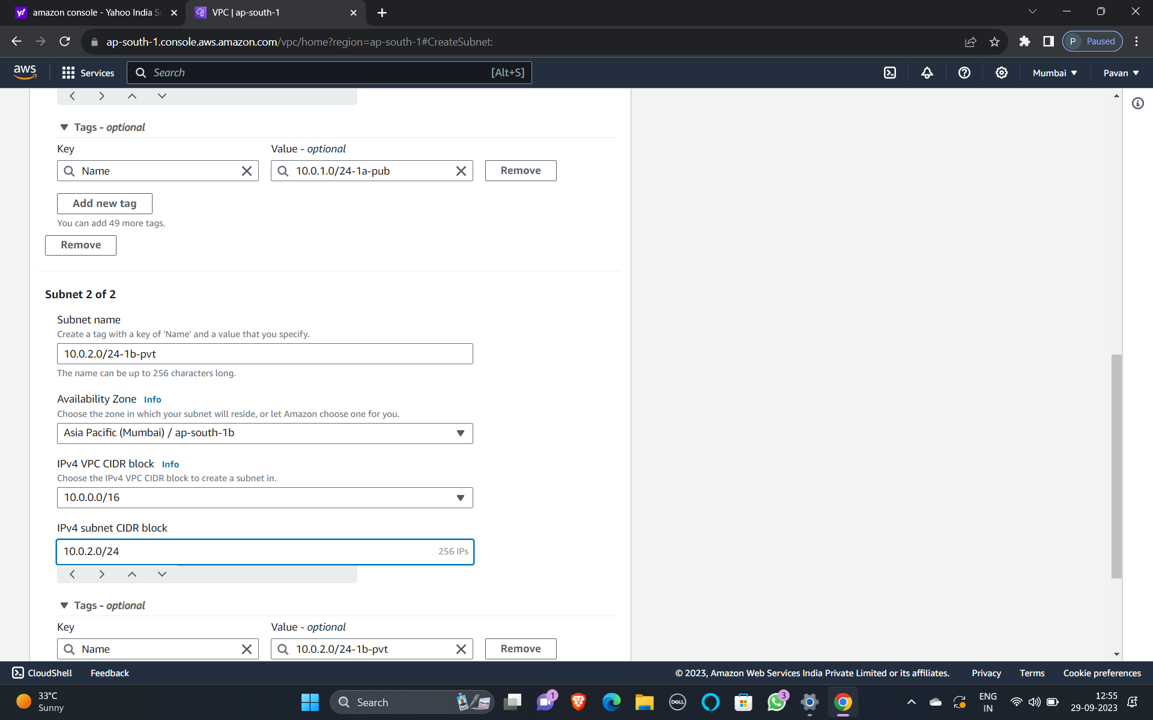

STEP 3: CREATING ROUTE TABLE

1)Naming

2)Create route table

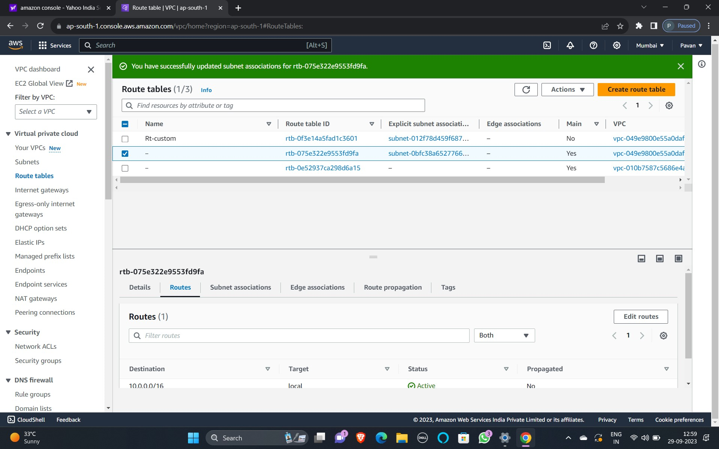

STEP 4: CREATING INTERNET GATEWAY

1)Naming

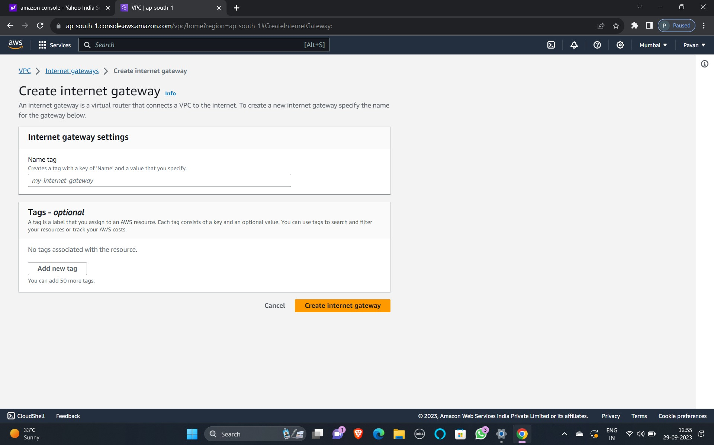

STEP 5: ATTACHING TO VPC

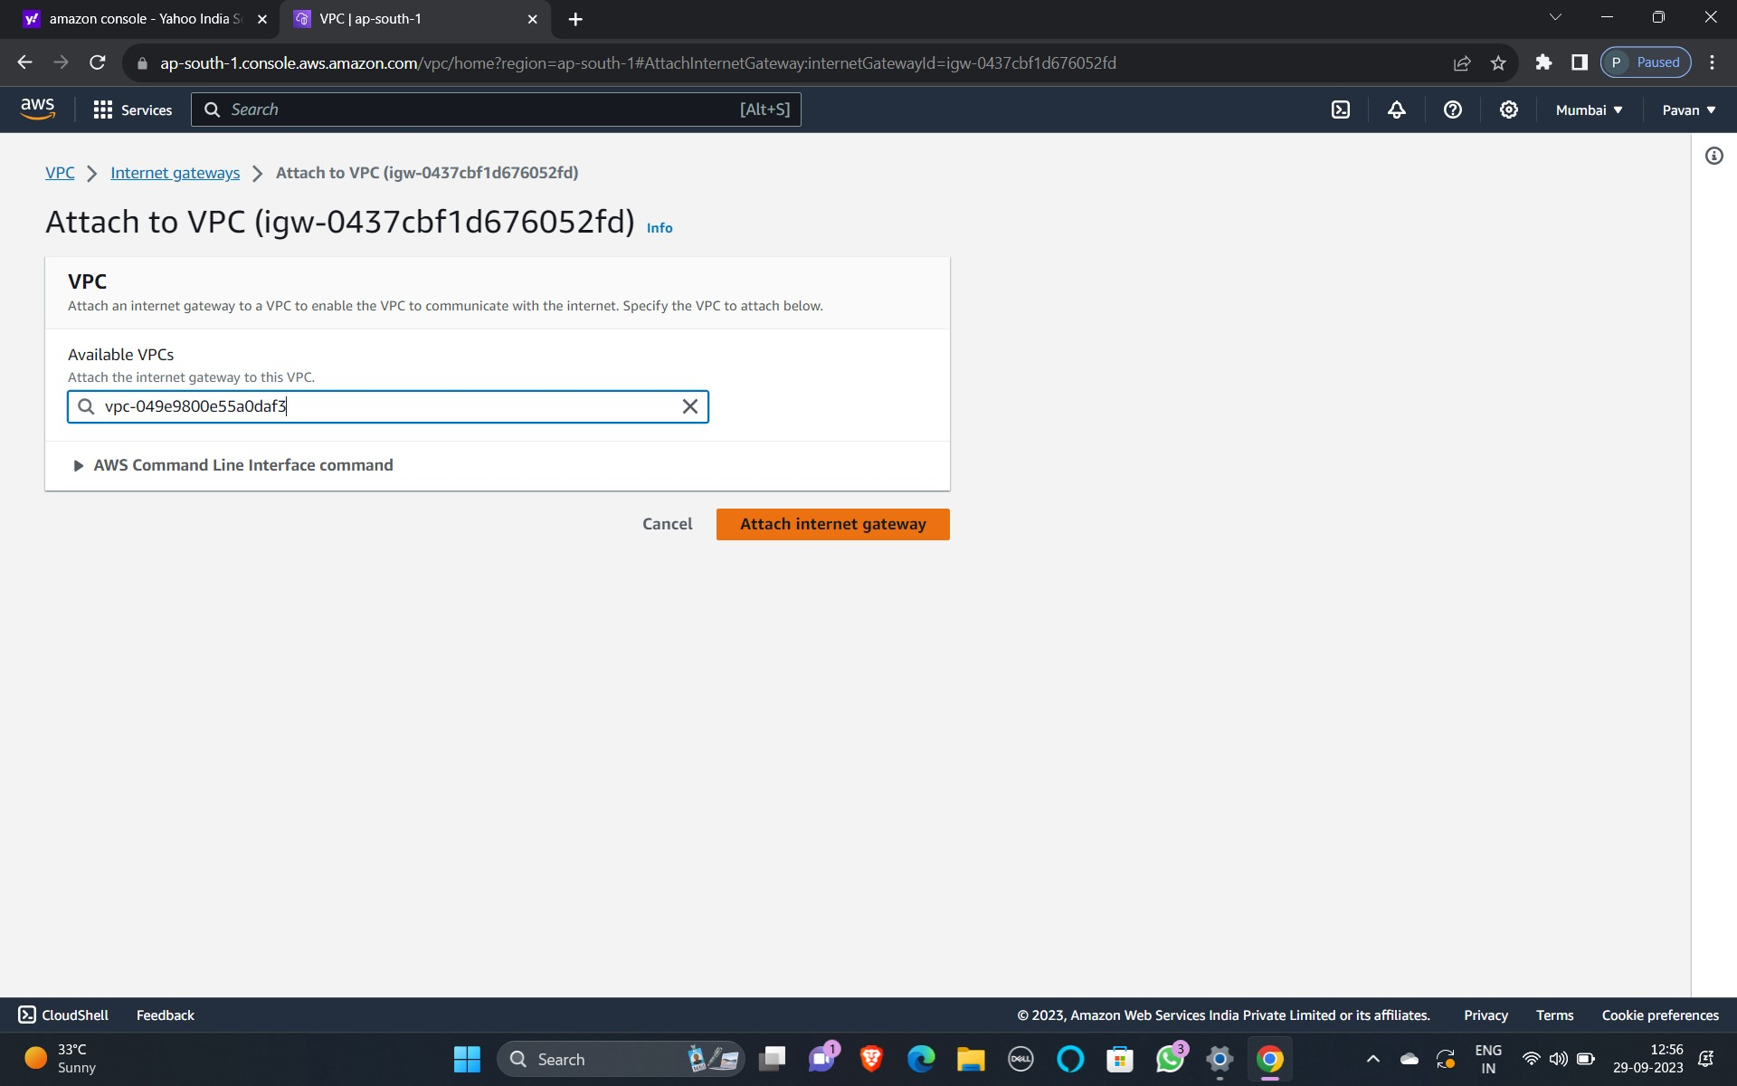

STEP 6: CONNECTING TO PUBLIC SUBNETS FROM IGW

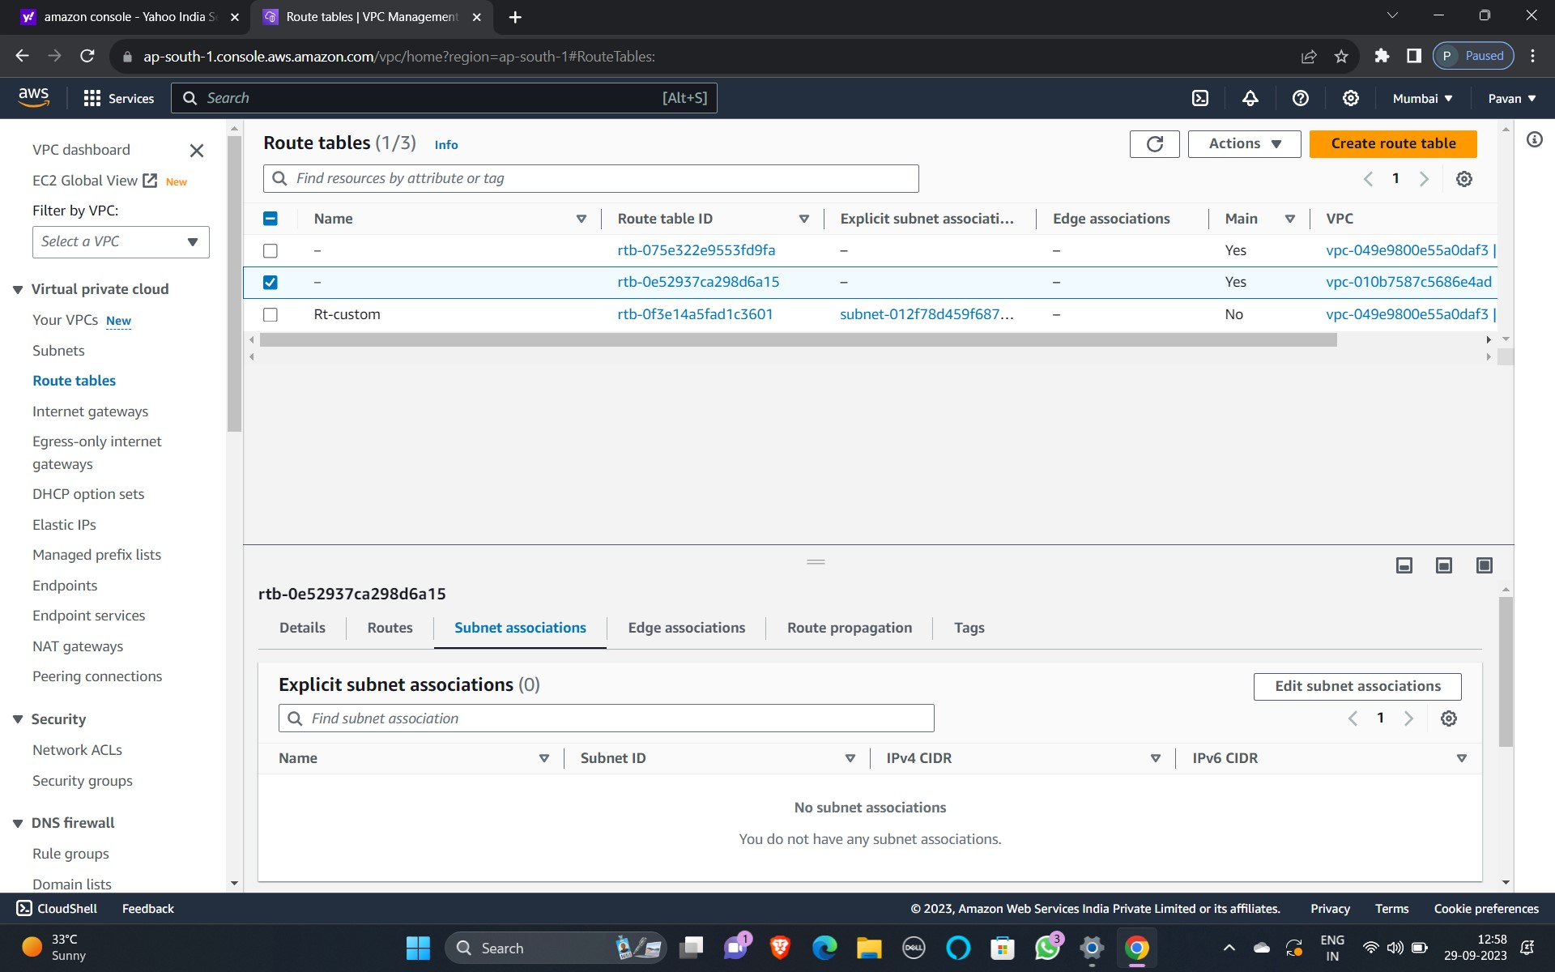

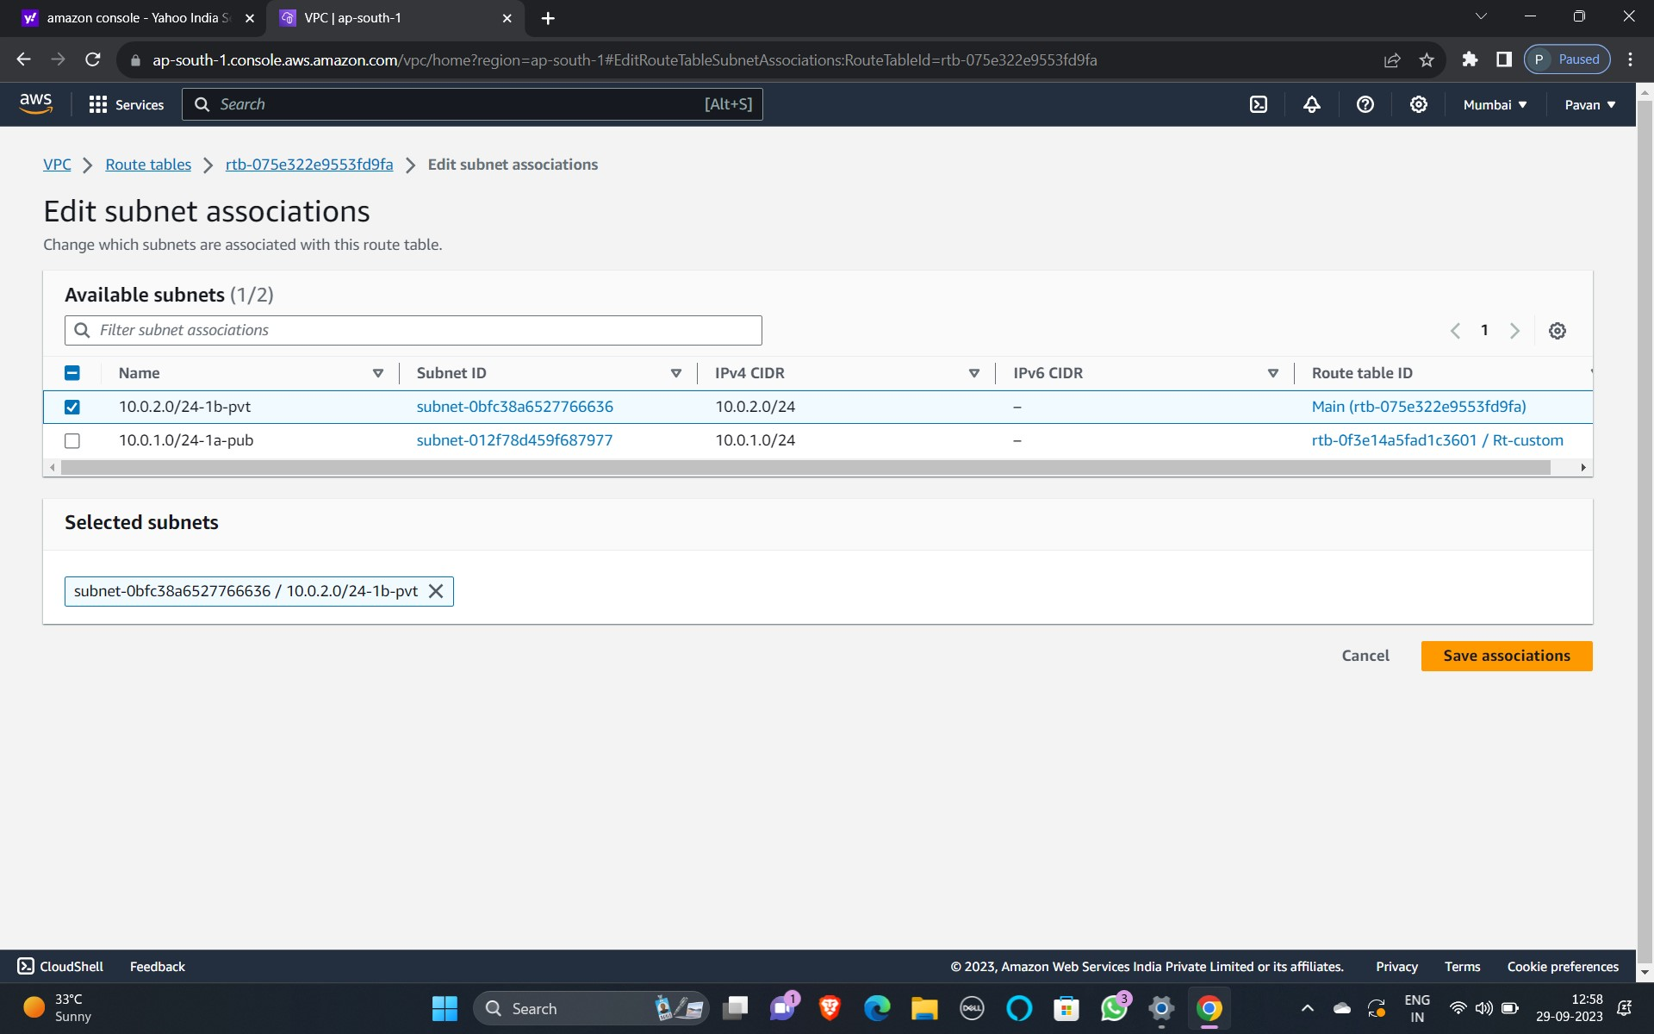

STEP 7: CREATING NAT GATE WAYS

1)NAMING

2)SELECT PUBLIC SUB NET

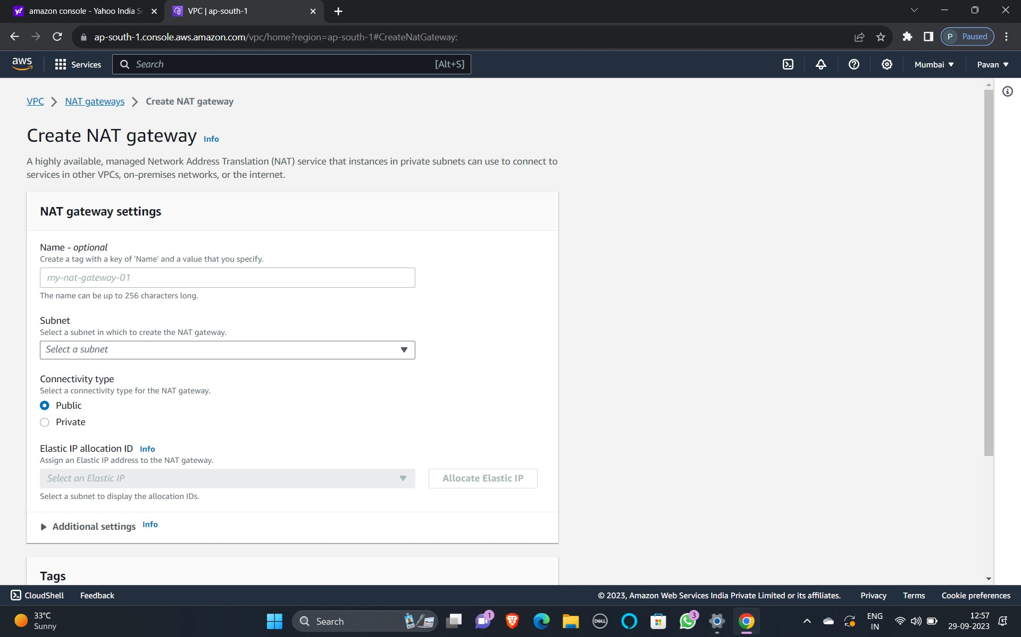

STEP 8: CONNECTING TO PRIVATE SUBNETS FROM NAT

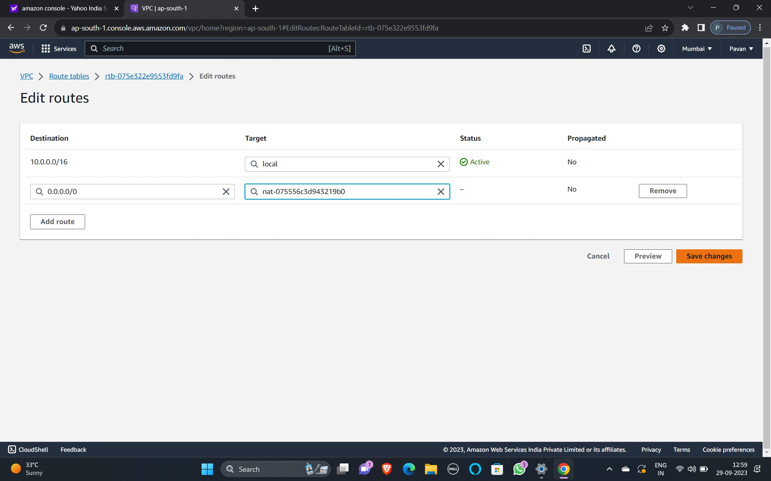

STEP 9: COMPLETION OF NETWORK CREATION

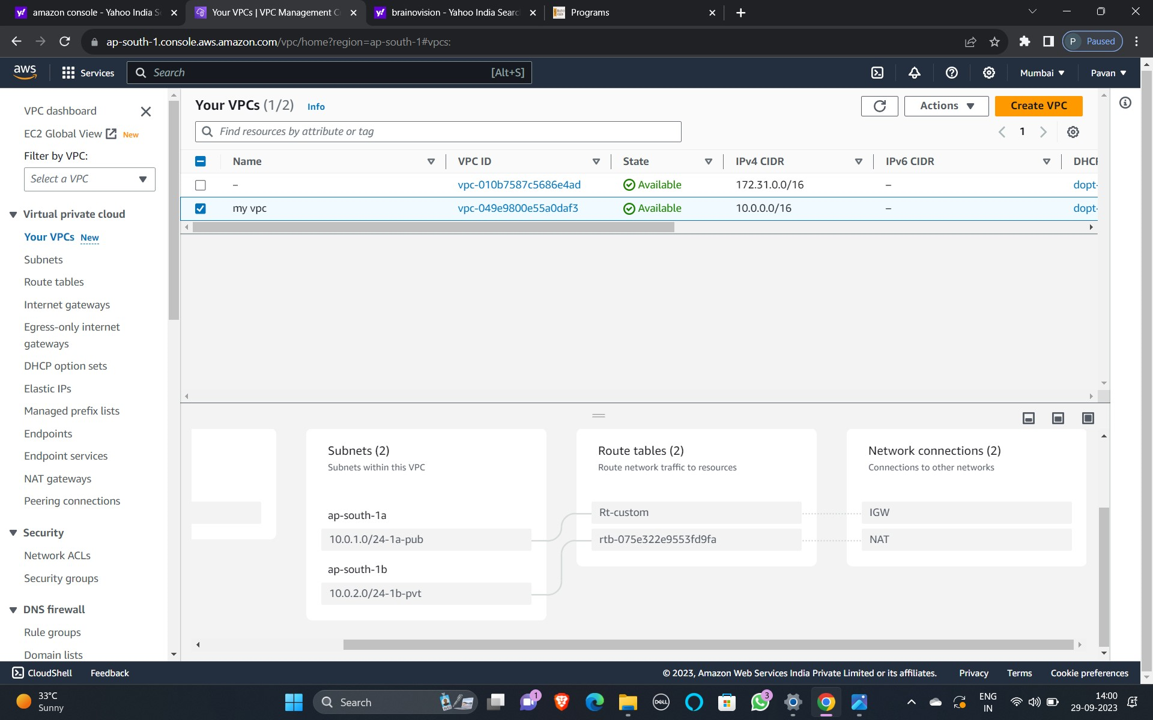



PROJECT CREATION:

STEP-1: CREATING ELB (elastic load balancer)

1)Select classic load balancer

2)Select all three mappings

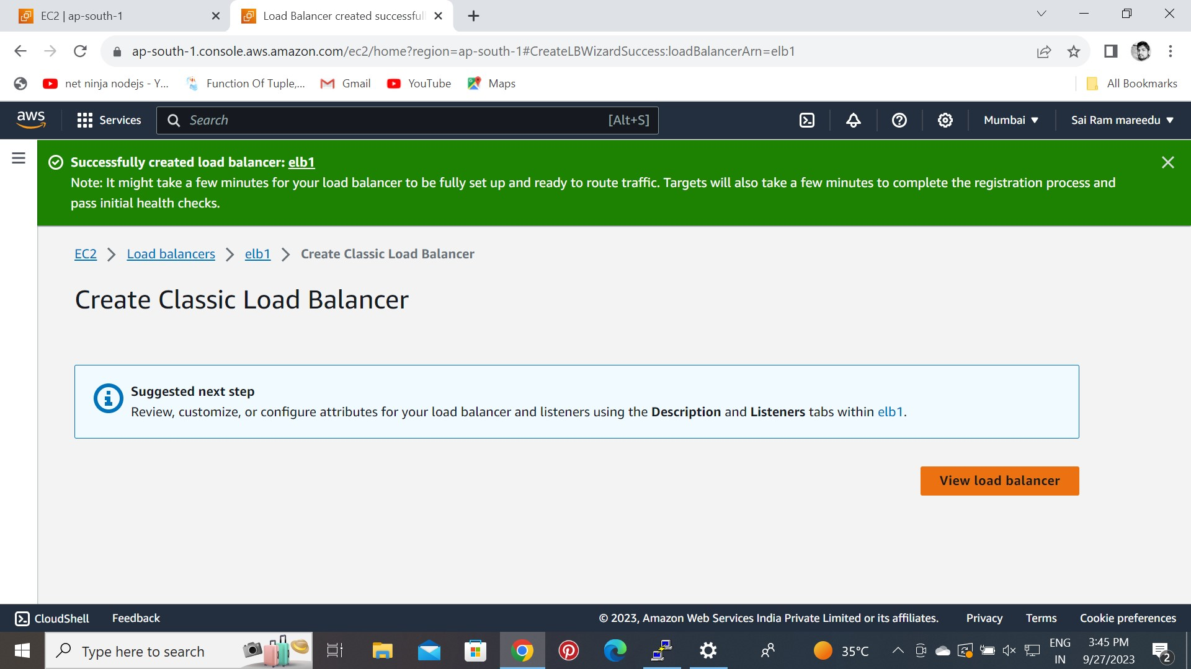

STEP-2: LAUNCHING TEMPLATE

1)Name of theTemplate :- my-temp

2)Select ASG (AUTO SCALING GUIDANCE)

3)Select IAM in advance details

4)Giving bin bash commands in advanced settings.

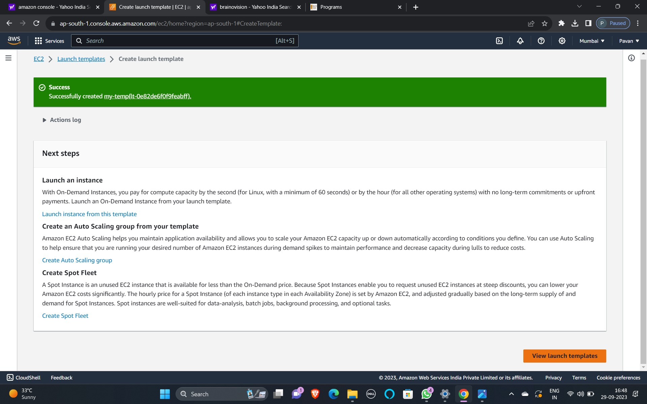

STEP- 3: Creating ASG (auto scaling groups)

1)Attaching Template

2)Selecting availability ZONES

3)Attaching ELB

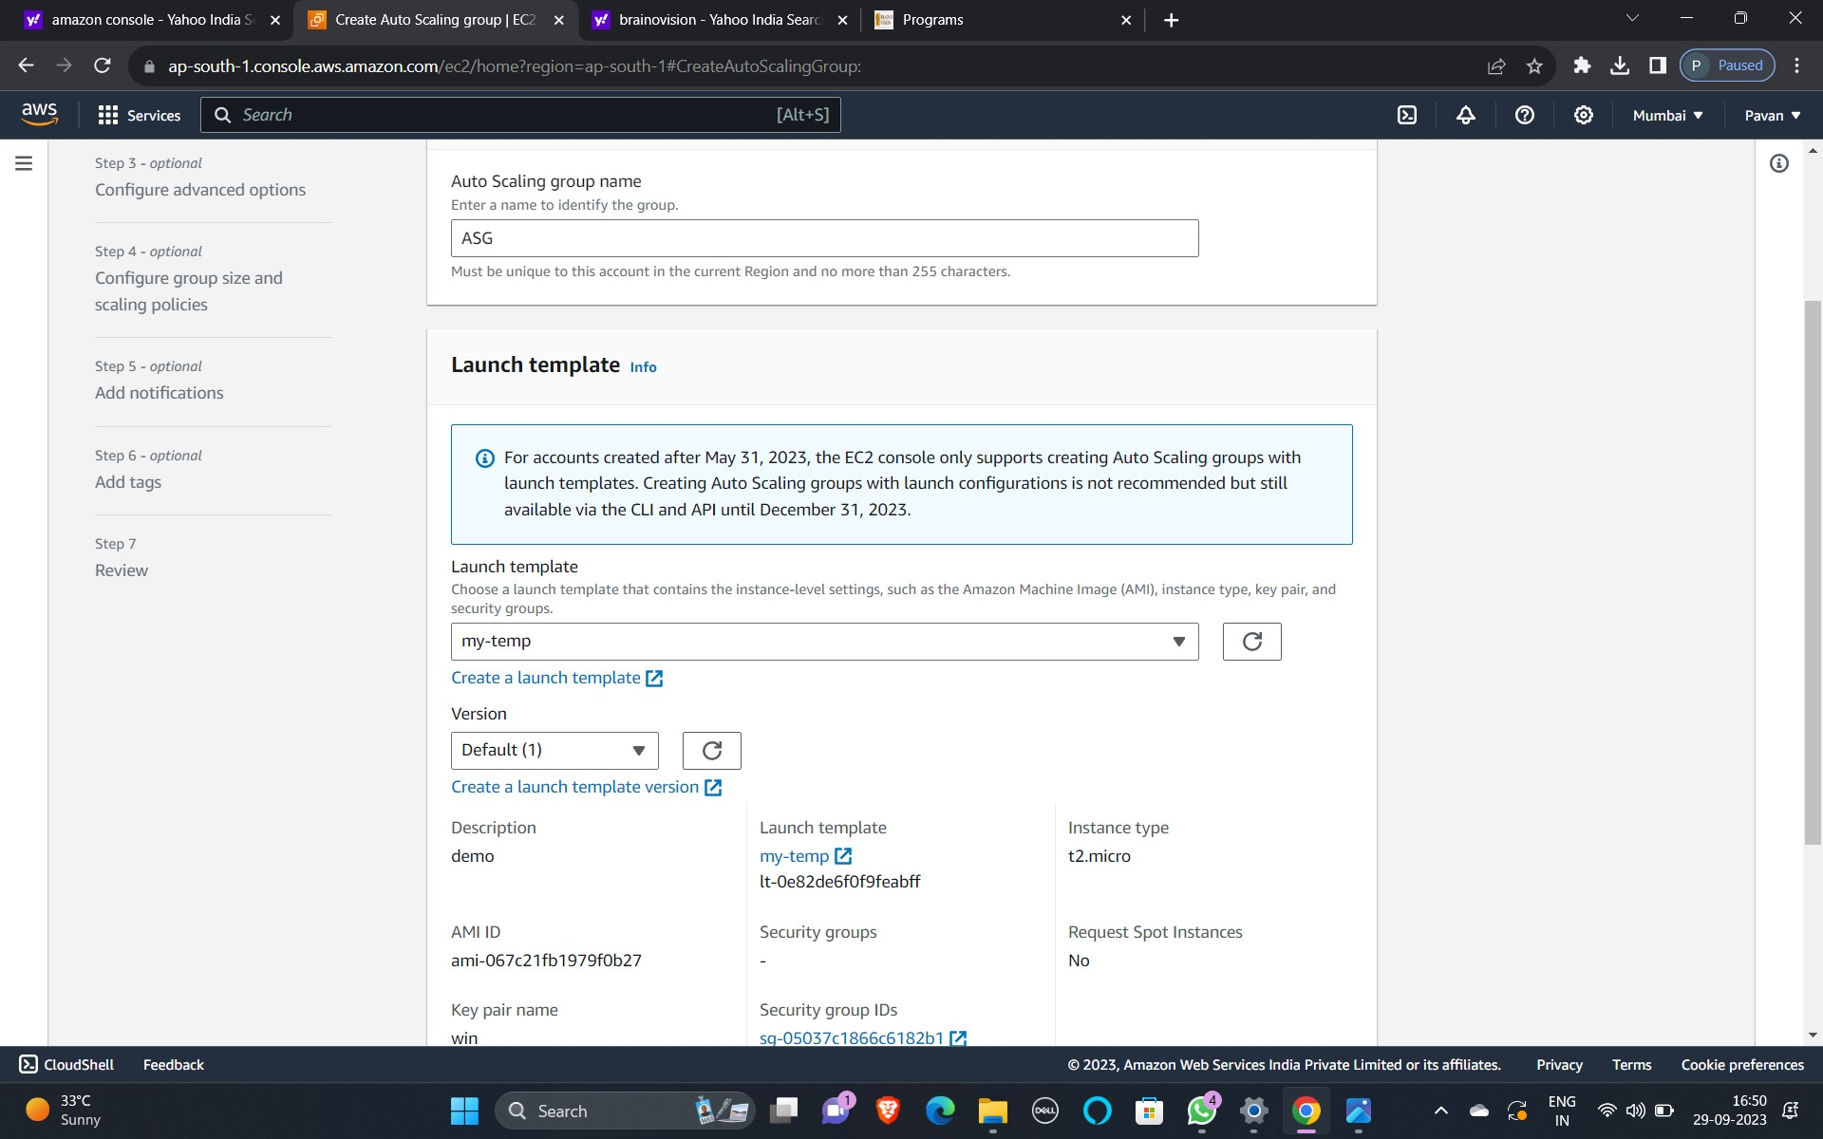

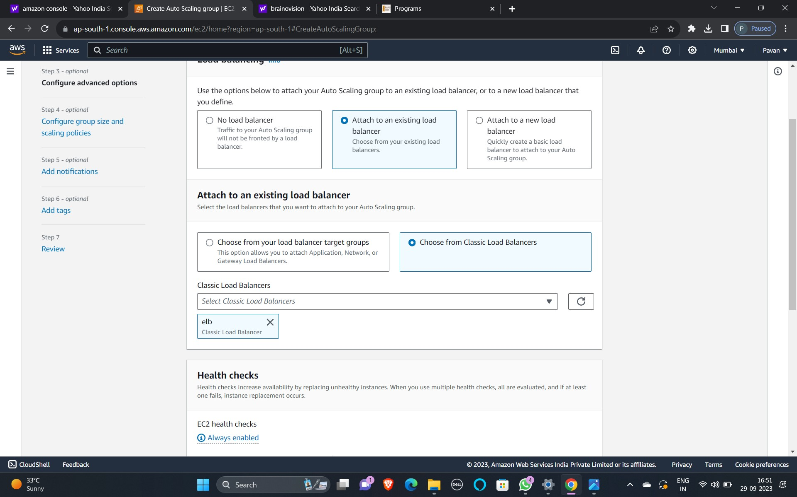

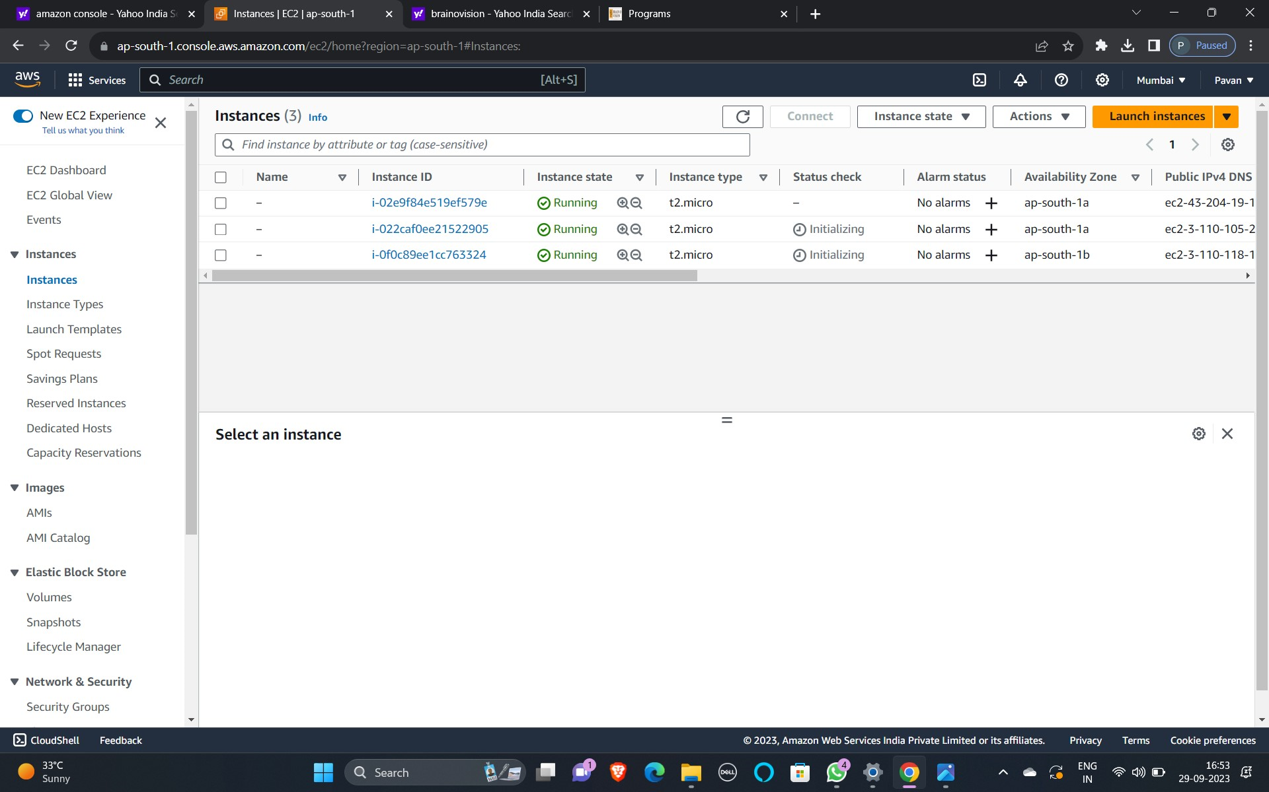

STEP-4: CREATING ROLES IN IAM

1)search for IAM

2)Select Create role

3)select AWS Services

4)Select EC2

5)Go to permission policies and select amazon S3 full access

6)name the Role

7)tags are optional and Click create Role.

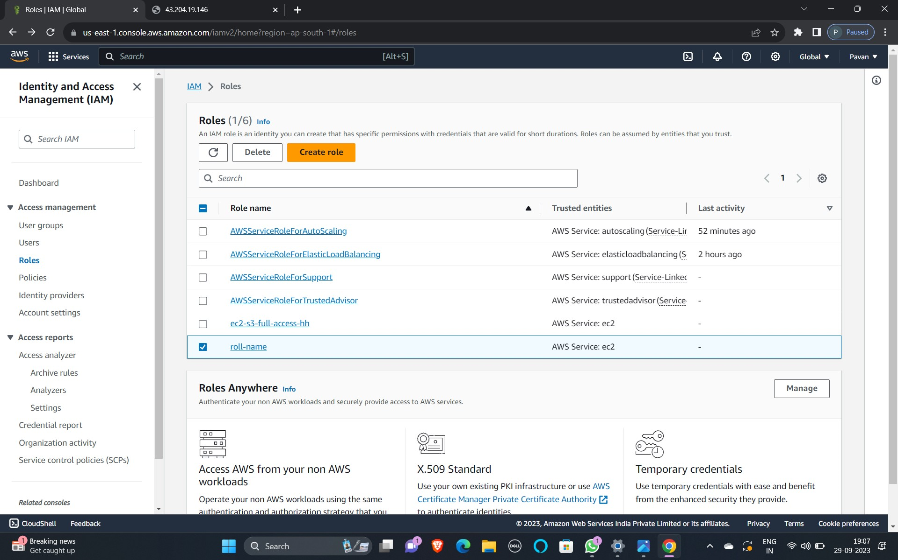

STEP-5:CREATING BUCKETS

1)Select any one of the launched Instances

2)Copy the selected instances DNS addresses

3)Go to PUTTY and paste the host name

4)Go to SSH and select the AUTH in that Browse credentials

5)Launch PUTTY

6)Login as a EC2 User

7)Create Buckets by using commands

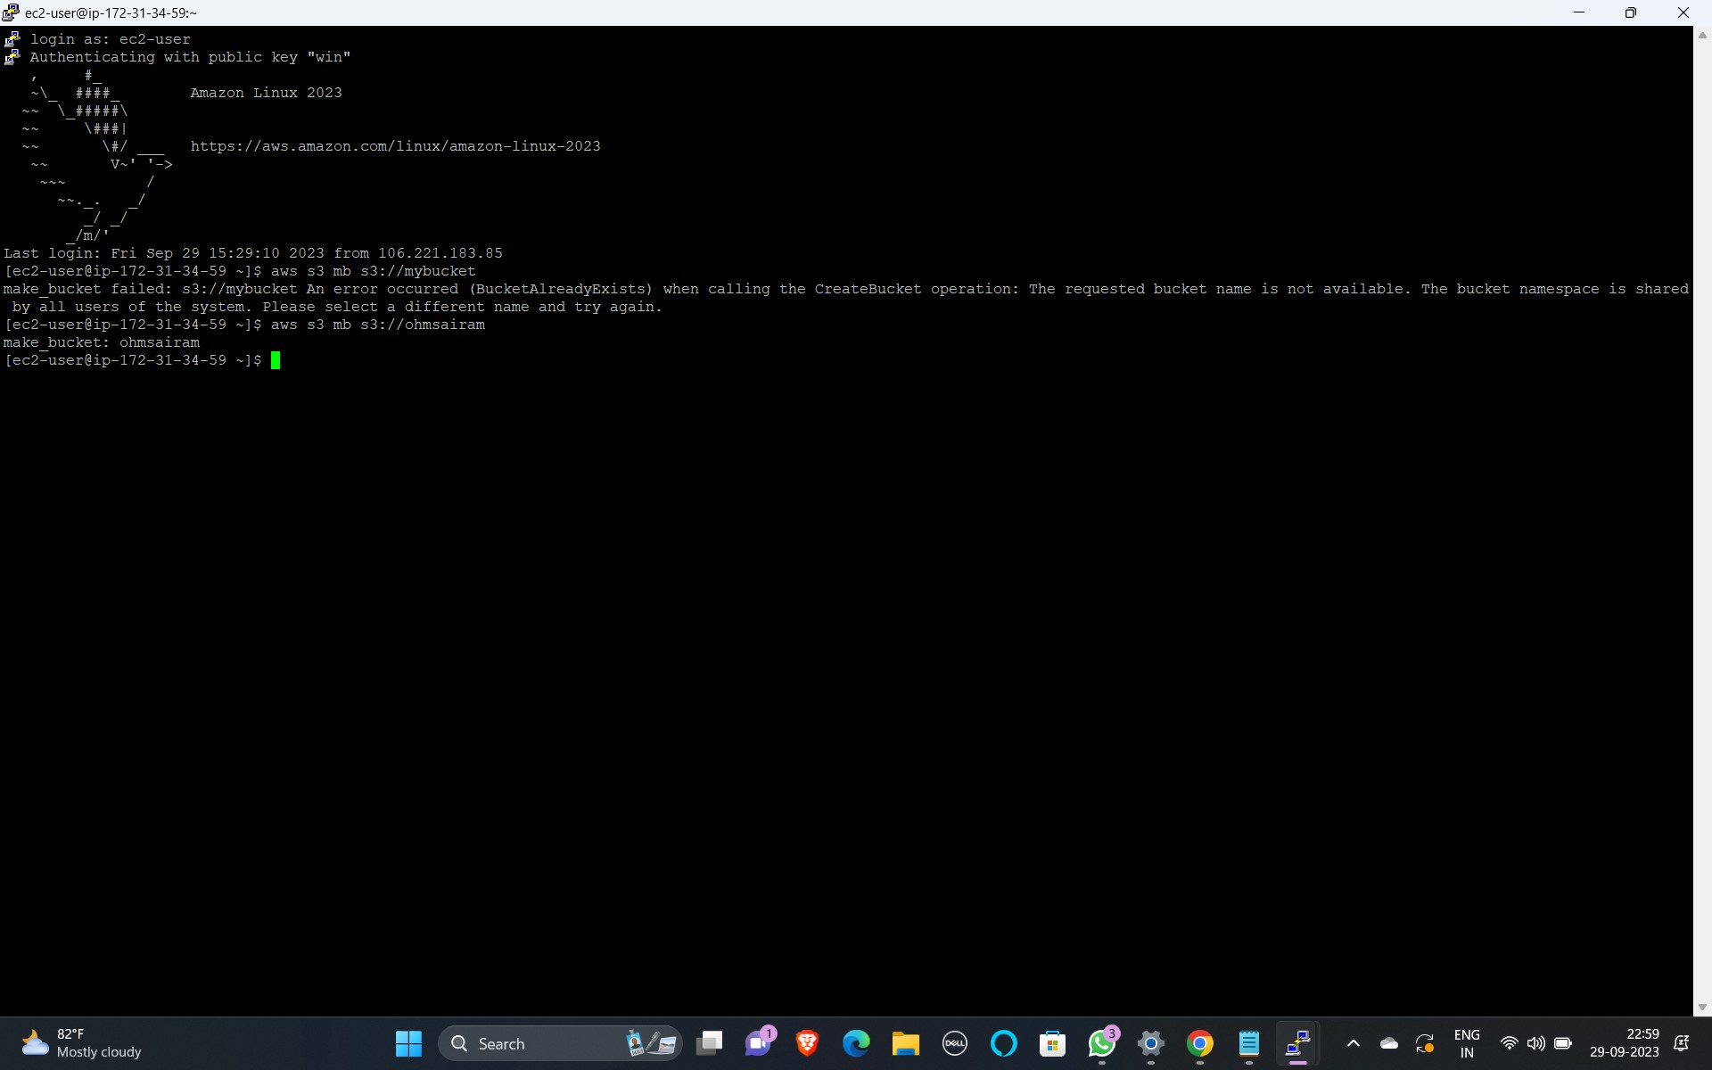

STEP-6: MAKING BUCKETS AS PUBLIC

1. Go to S3 and Select Buckets
2. We have to edit created bucket that was created through PUTTY
3. Go to permissions and Edit public Access
4. Go to Bucket Policy and Enter the Code

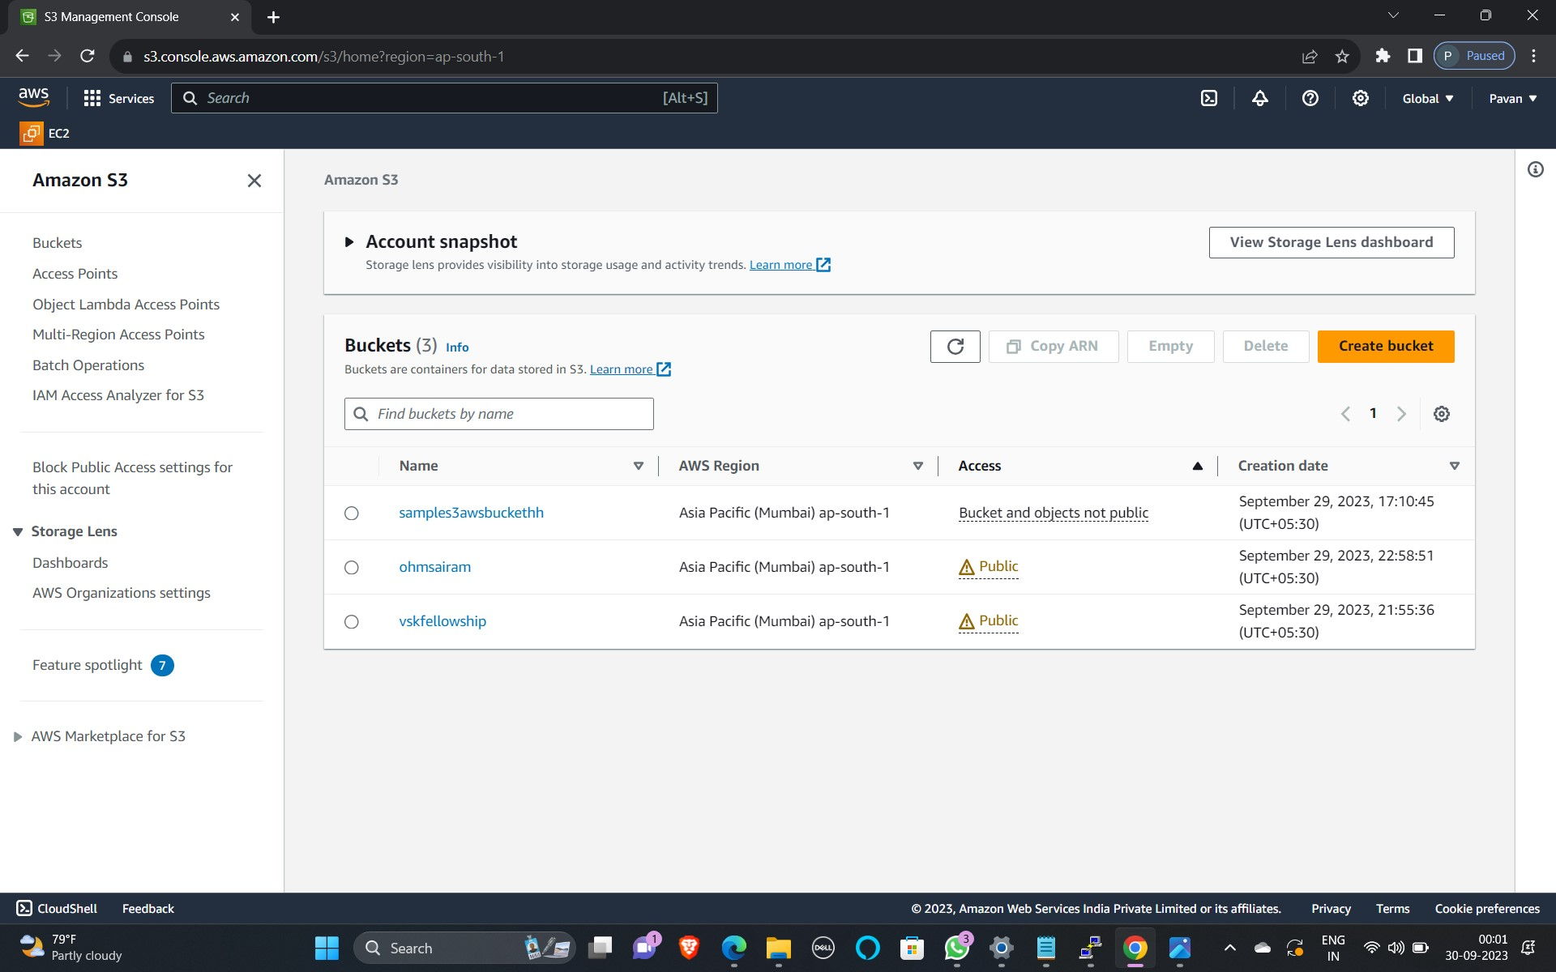

STEP-7: ATTACHING OBJECT TO BUCKET

1. Select a bucket name
2. Upload object file

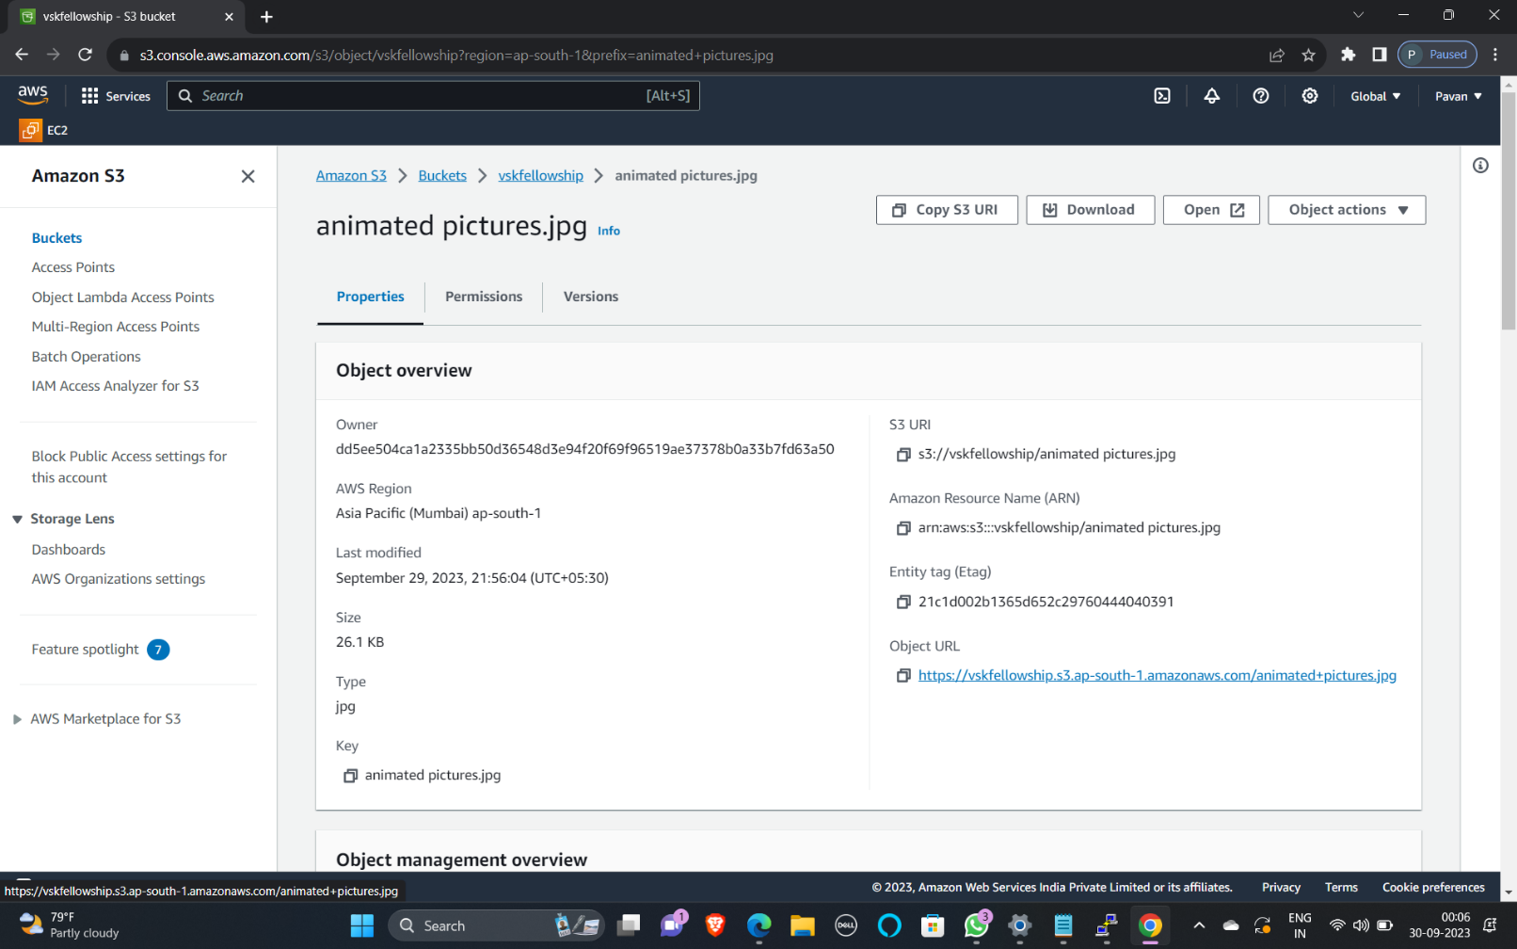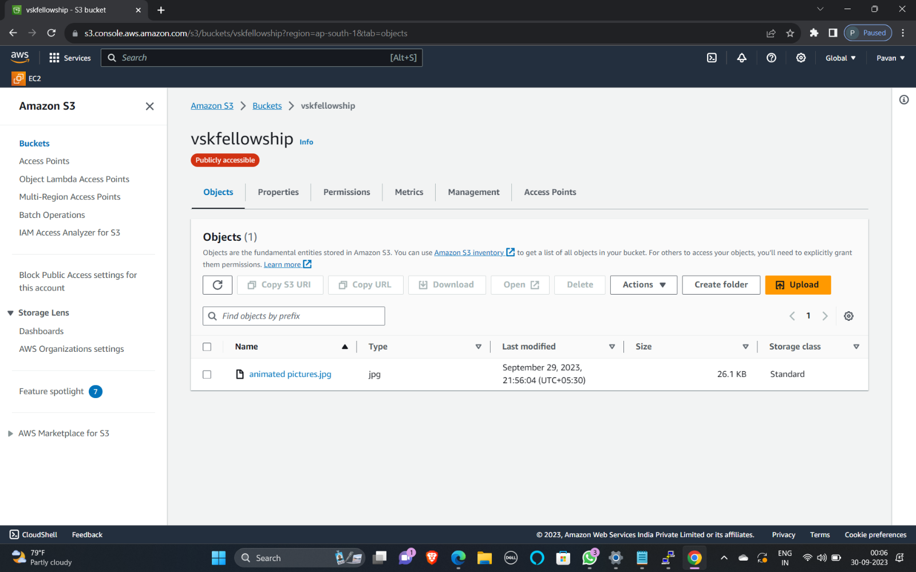



**DATA BASE CONNECTIVITY:**

**STEP 1: Create a jump box**

1. Create instance
2. In AMI Select Amazon Linux
3. Instance type = t2.micro
4. Creating Key-Pair
5. Edit network Settings
6. Launch Instances

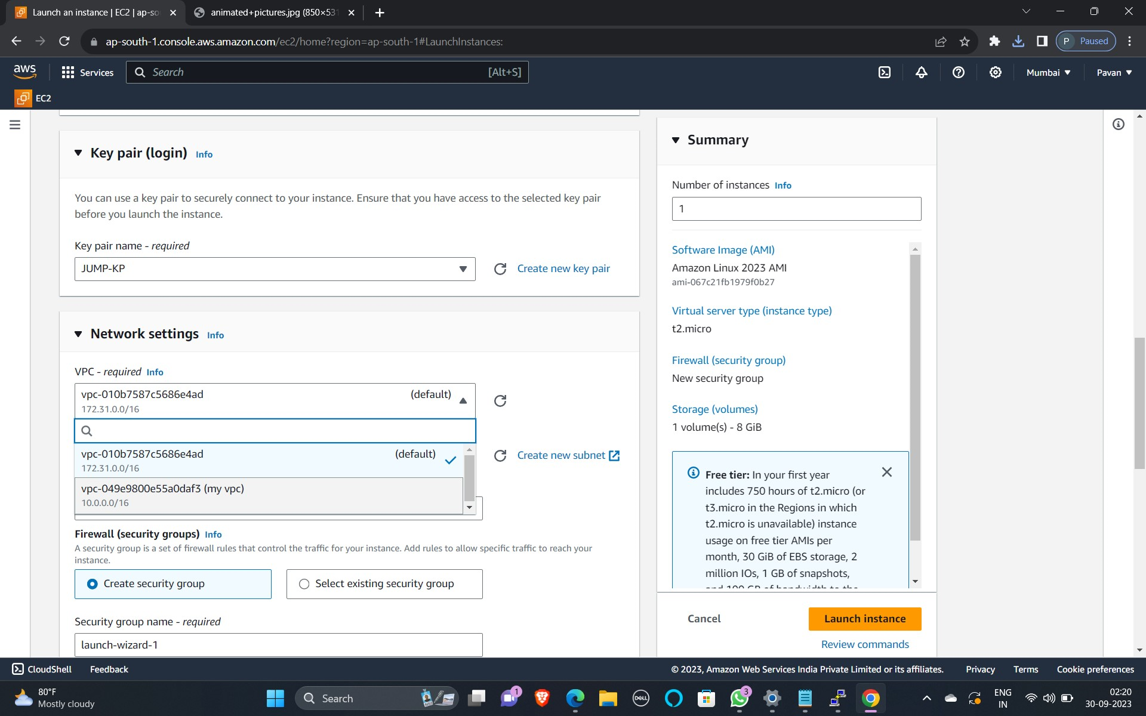

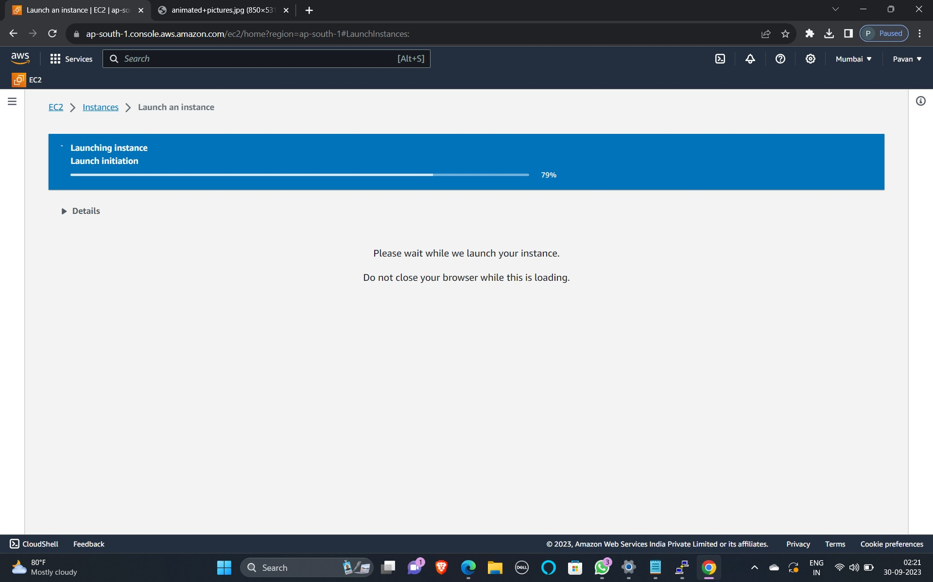

**STEP 2: Creating a database server**

1. Create instance
2. In AMI Select Amazon Linux
3. Instance type = t2. micro
4. Creating Key-Pair
5. Edit network Settings
6. Launch Instances

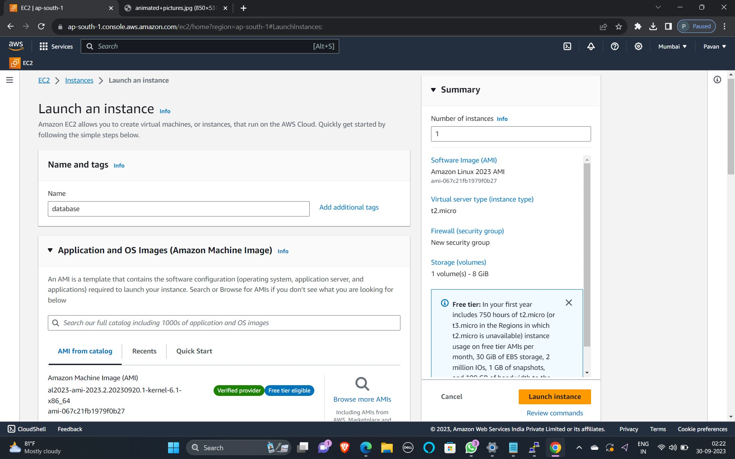

**STEP 3: Connecting Database Server with Jump box**

1. Select Jump box and click on SSH client
2. Click on SSH and Copy public IPv4 of jump
3. Open PUTTY software
4. Give public IPv4 of jump as Hostname
5. In connections go to SSH and select AUTH
6. In AUTH, Select credentials and upload PPK file
7. Connect Instances

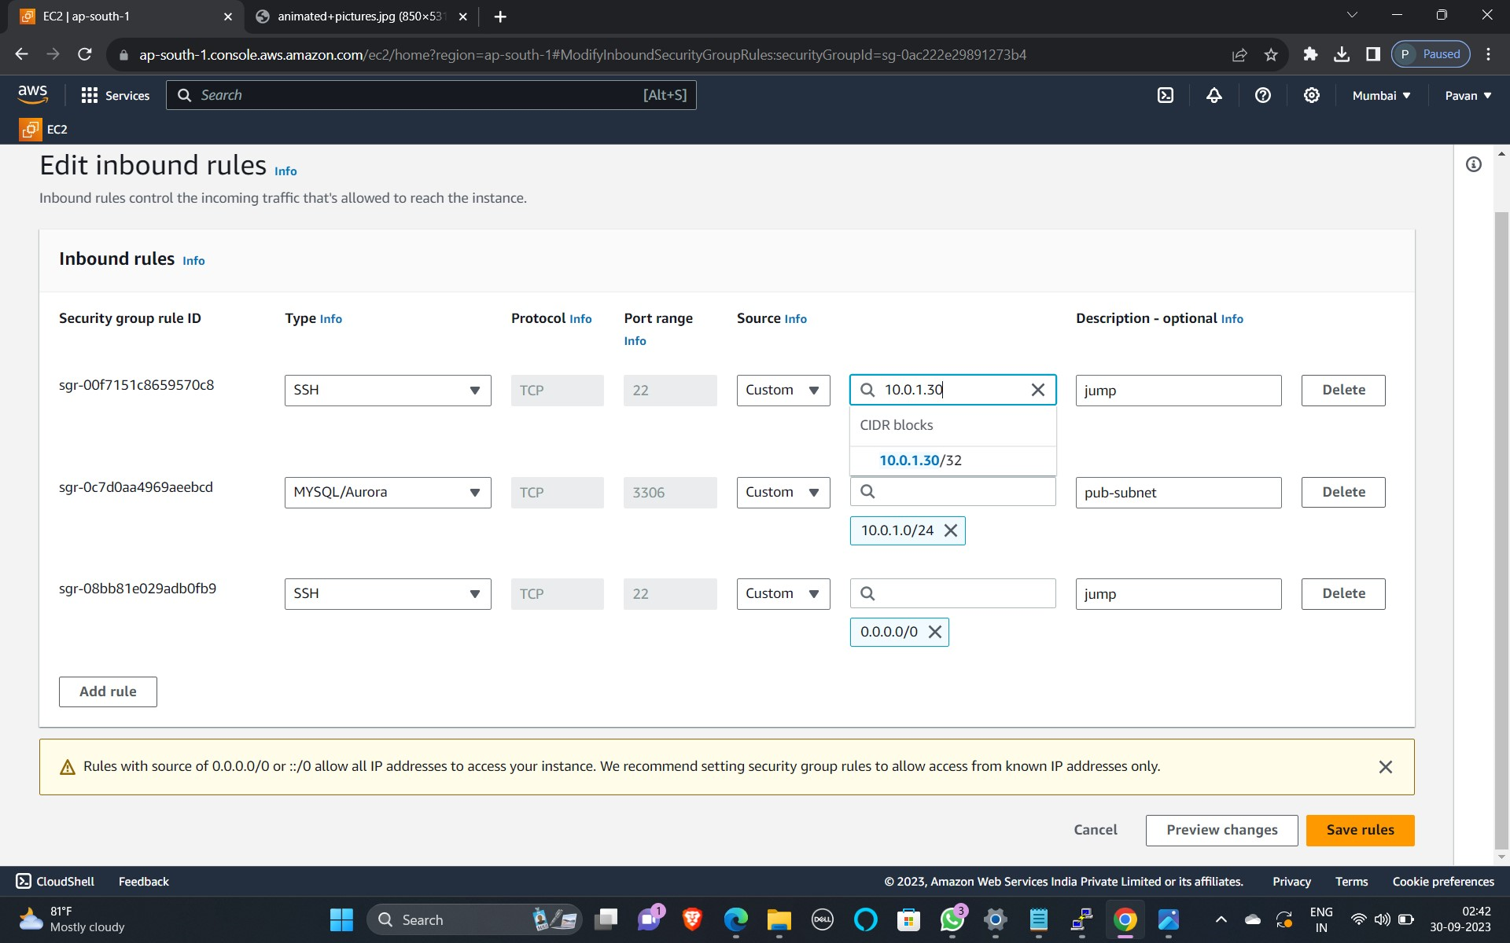

**STEP 4: Connecting to the Database Server**

1. Install WINSCP software
2. open your WINSCP software
3. Give host as a public IP of jump box
4. Give username : EC2-user
5. Go to Advanced settings
6. In connections go to SSH and select AUTH
7. In AUTH, Select credentials and upload PPK file
8. Login to WINSCP software
9. Drag Database key files and paste in the jump box

10)Close WINSCP app

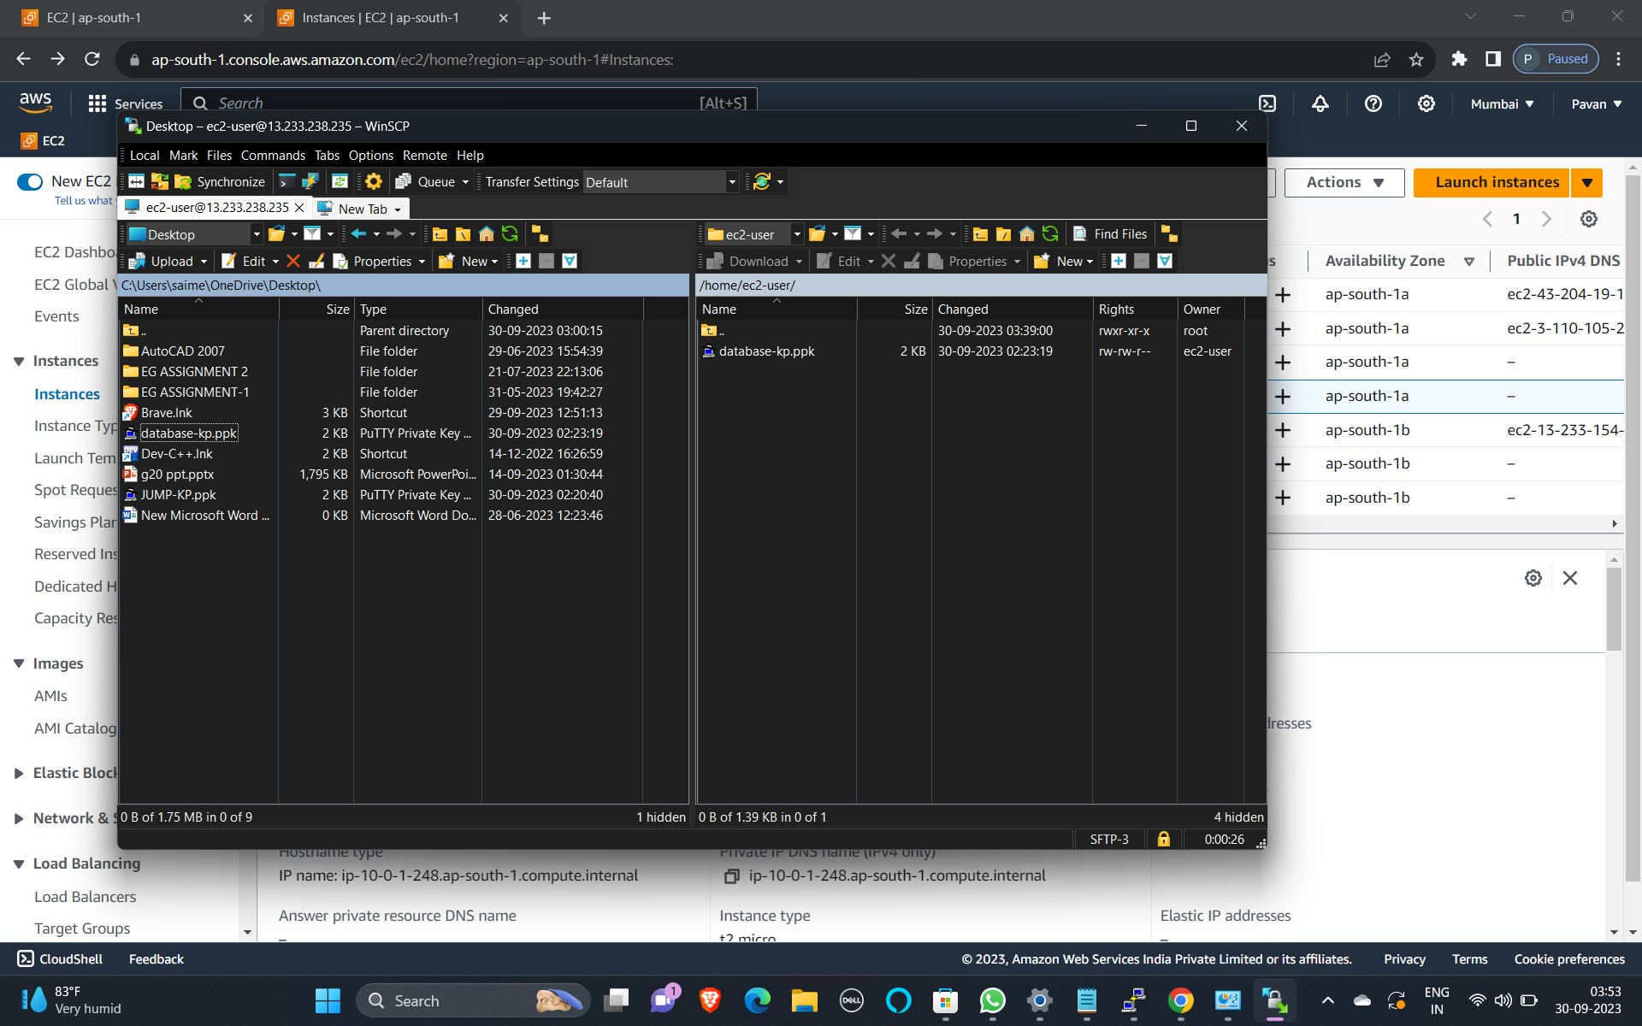

**STEP 5: Database Connectivity**

1. Go to database server and connect
2. Go to SSH and copy jump box IP
3. paste in PUTTY of the jump instance
4. Finally, database is connected using jump box



**INACTING INFRASTRUCTURE:**

**STEP 1: Go to VPC**

1. Go to Security
2. Go to network ACL’s
3. Create NACL and Name: NACL custom
4. Select VPC as MY-VPC

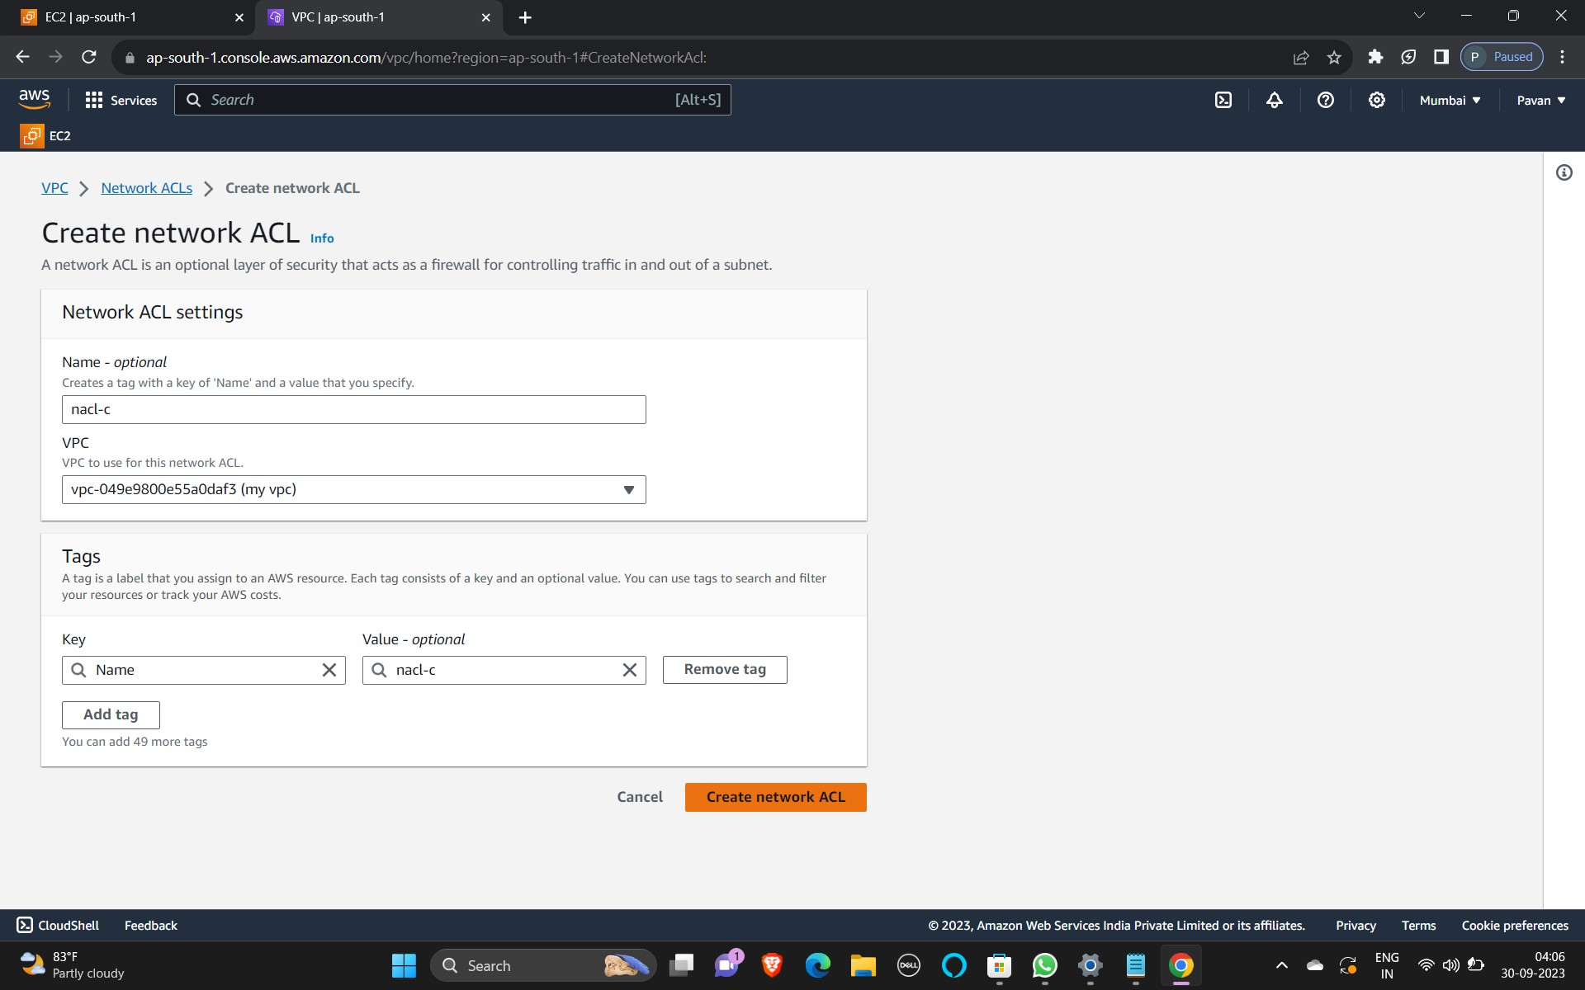

**STEP 2: Subnet Associations**

1. Go to Subnet Associations
2. Go to Edit Subnet Associations
3. Edit inbound, outbound rules

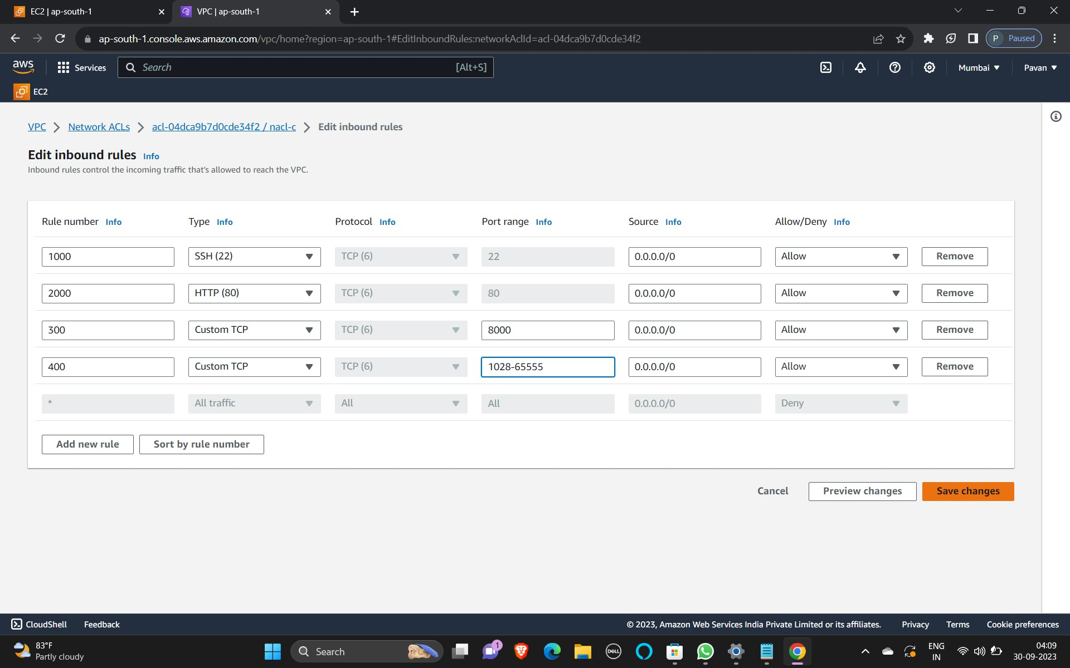

**STEP 3: Create a NAT(Network Address Translation)**

1. Give the NAT Name
2. Allocate ELB
3. Select name: MY-VPC



**STEP 4: Connecting to webserver using PUTTY**

1. Go to SSH and copy public IPv4 of jump
2. Open PUTTY software
3. Give public IPv4 of jump as host name
4. Go to Connections and select SSH, in SSH select AUTH
5. In AUTH, select credentials and upload PPK file
6. Connect the instance

